Which type of scheduler xv6 uses?  
  
The existing scheduler in xv6 is a Round-Robin (RR) scheduler. On each timer interrupts, the interrupt handler switches to the kernel scheduler, which then selects the next available process to run.

On the images below, one can see the next lines:  
  
// Switch to chosen process. It is the process's job

// to release ptable.lock and then reacquire it

// before jumping back to us.

proc = p;

switchuvm(p);

p->state = RUNNING;

swtch(&cpu->scheduler, proc->context);

switchkvm();

// Process is done running for now.  
  
Where the context switch is represented by the swtch() function. And also the last line (that is commented) mentions how the process is done running for now, referencing how the process itself have a time that it will run before switching, which is called a quantum. Which is what defines Round-Robin.  
  
Images of code in proc.c:  
  
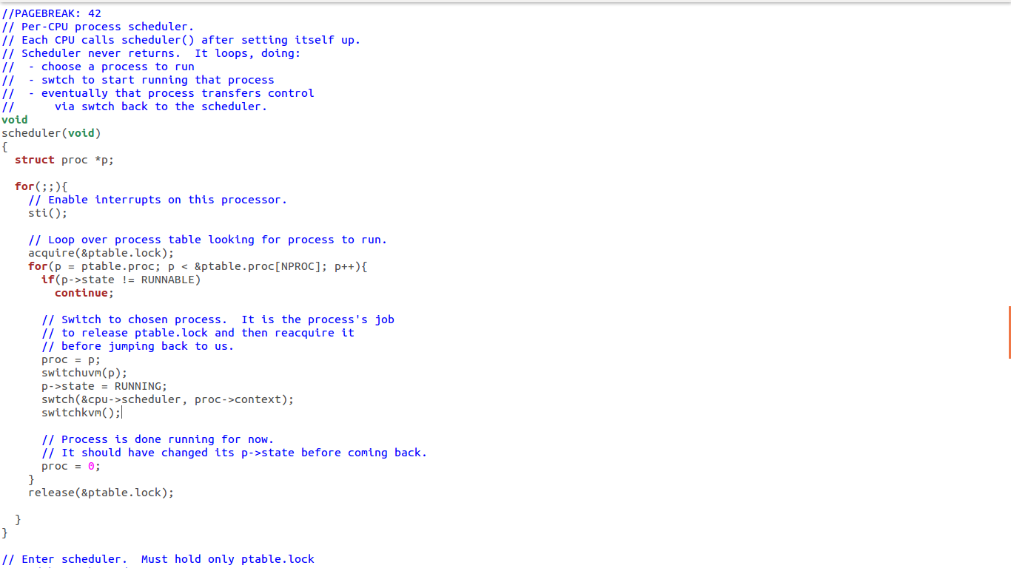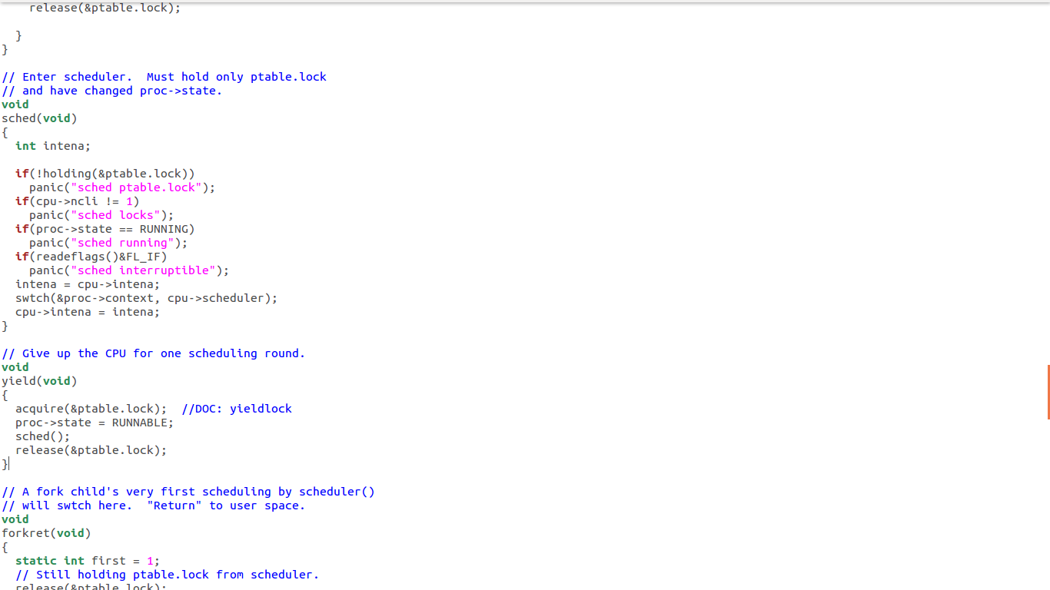  
  
Source: http://www.cs.columbia.edu/~junfeng/11sp-w4118/hw/hw4.html